**Investigation of “Weekend Effect”**

**Investopedia Definition:**

Weekend Effect is a phenomenon in financial markets in which stock returns on Mondays are often significantly lower than those of the immediately preceding Friday.

Some theories that explain the effect attribute the tendency for companies

to release bad news on Friday after the markets close to depressed stock prices on Monday. Others state that the weekend effect might be linked to short selling, which would affect stocks with high short interest positions.

**After Hours in the U.S.:**

1) 4:00 p.m. to 8:00 p.m. ET, and 2) 4:00 a.m. to 9:30 a.m. ET

**STAP 1**

Caption: Row SP500 Data

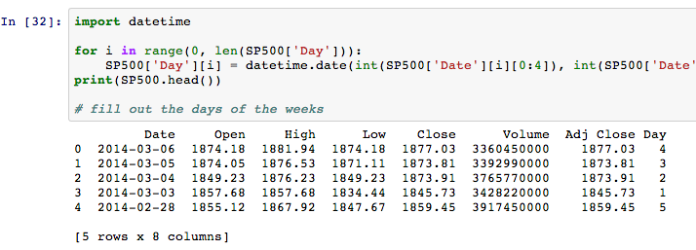

Note: Adding a column that denotes day of the week for each row.

**STAP 2**

Caption: Overnight Rate of Return by Day of the Week

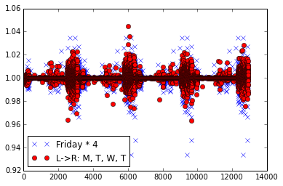

Note: Define Overnight Rate of Return as Open Quote over preceding Adjusted Close Quote for each trading day, and plot the rates in Friday vs. other Days of the Week.

**STAP 3**

Caption: Histogram of Friday and Non-friday

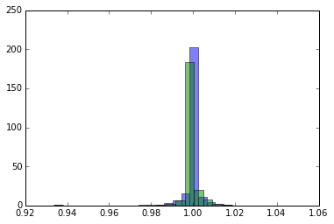

Note: Generate normalized histograms for Friday Group and Non-Friday Group in terms of previously defined “Overnight Rate of Return.” Notice the slight discrepancy in distribution.

**STAP 4**

Caption: Conventional Nonparametric Test Statistic

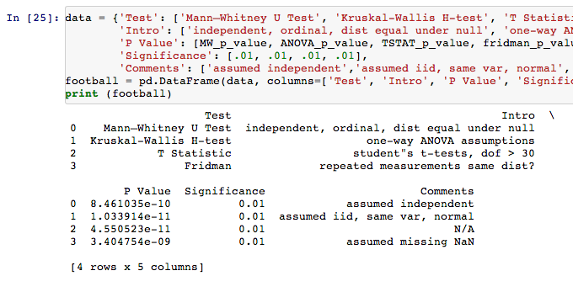

Note: Run conventional nonparametric statistical tests to study possible difference in distributions between the groups.

**STAP 5**

Caption: Triweight Kernel Estimation, Bootstrapping Sample vs. Population

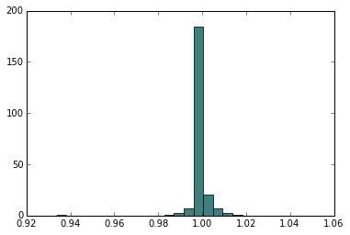

Note: Kernel estimation on the experiment group (i.e. Friday), and sample from the distribution. Plot the original data against the sampled data, whose normalized histograms coincide.

**STAP 6**

Caption: Bootstrapping MC Sampled Control Group (Friday)

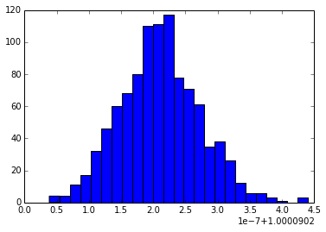

Note: Bootstrap the MC sampled experiment group (i.e. Friday), and defined quantity of interest being T = mean(bootstrap Friday*). We obtain a distribution of the Friday sample mean.

**STAP 7**

Caption: Sample Mean Bootstrap, Experiment Group vs. Control Group

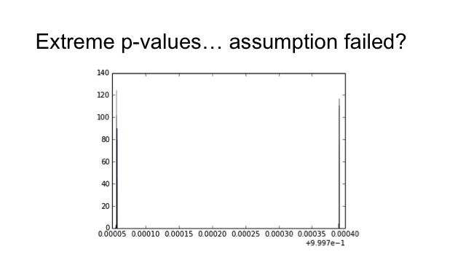

Note: Repeat Step 5, 6 for the Control Group (i.e. Non-Friday). Plot the respective histograms of sample mean. P-value is abnormally small, which indicates the research model might not be satisfactory. Possible assumptions might fail, for example: Experiment Group data are not independent from Control Group.